**BUSINESS REQUIREMENTS**

1. **Tax per Return**

ALTER TABLE quarterlysalestax ADD COLUMN tax_per_return DECIMAL(18,4);

UPDATE quarterlysalestax

SET tax_per_return = CASE

WHEN number_of_returns > 0 THEN computed_tax / number_of_returns

ELSE 0 END;

1. **Tax per Sale**

ALTER TABLE quarterlysalestax ADD COLUMN tax_per_sale_ratio DECIMAL(18,6);

UPDATE quarterlysalestax

SET tax_per_sale_ratio = CASE

WHEN taxable_sales > 0 THEN computed_tax / taxable_sales

ELSE 0 END;

1. **Top-N Queries for Power BI**
   1. **Top 10 Counties by Computed Tax**

SELECT county, SUM(computed_tax) AS total_tax

FROM quarterlysalestax

GROUP BY county

ORDER BY total_tax DESC

LIMIT 10;

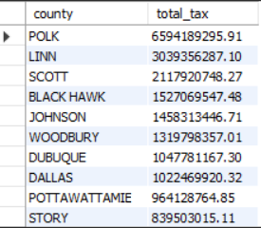

* 1. **Computed Tax by Quarter**

SELECT fiscal_year, quarter_ending, SUM(computed_tax) AS total_tax

FROM quarterlysalestax

GROUP BY fiscal_year, quarter_ending

ORDER BY quarter_ending;

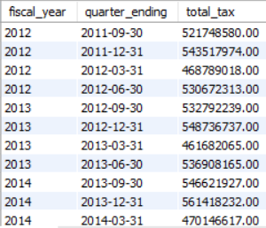

* 1. **County Contribution Percentage**

SELECT

county,

SUM(computed_tax) AS total_tax,

ROUND(SUM(computed_tax) * 100 /

(SELECT SUM(computed_tax) FROM quarterlysalestax), 2) AS percent_contribution

FROM quarterlysalestax

GROUP BY county

ORDER BY percent_contribution DESC;

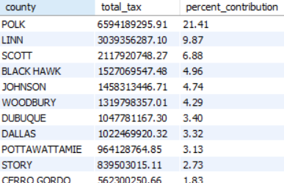

1. **Anomaly Detection (SQL Pre-Flagging)**
   1. **Mark rows with unusually high tax_per_sale_ratio (using standard deviation threshold)**

-- Get avg and stddev

SELECT

AVG(tax_per_sale_ratio) AS mean_val,

STDDEV(tax_per_sale_ratio) AS std_val

INTO @mean_val, @std_val

FROM quarterlysalestax;

-- Add anomaly flag column

ALTER TABLE quarterlysalestax ADD COLUMN anomaly_flag VARCHAR(10) DEFAULT 'Normal';

-- Update flag

UPDATE quarterlysalestax

SET anomaly_flag = 'Anomaly'

WHERE ABS(tax_per_sale_ratio - @mean_val) > 2 * @std_val;

REQUIRED CHARTS FOR VISUALIZATION

1. **KPI Cards (Top of Dashboard)**

* Total Computed Tax
* Total Returns
* Average Tax per Return

1. **Line Chart – Tax Revenue Over Time**

* **X-axis**: Quarter Ending
* **Y-axis**: Total Computed Tax
* **Legend**: County (optional)
* Add slicers for County and City.

1. **Bar Chart – Top 10 Counties by Computed Tax**

* **Axis**: County
* **Values**: Total Computed Tax
* **Sort**: Descending
* Filter top 10 using visual-level filters.

1. **Stacked Column Chart – Computed Tax by County per Fiscal Year**

* **Axis**: Fiscal Year
* **Legend**: County
* **Values**: Total Computed Tax